**NOTES FUNCTIONS AND INVERSES 2025**

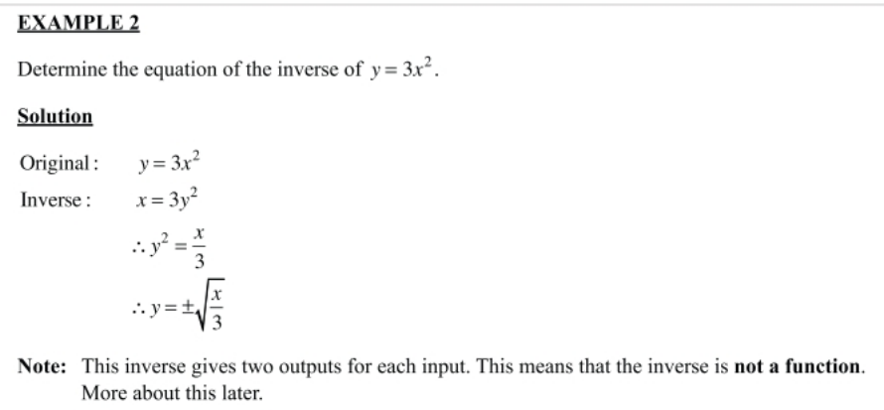

b) Sketch both f(*x*) = 3*x*2 and its inverse on the same set of axes.

*f(x)* = 3*x*2 

|  |  |  |  |
| --- | --- | --- | --- |
| ***x*** | **–1** | **0** | **1** |
| **y** | **3** | **0** | **3** |

|  |  |  |  |
| --- | --- | --- | --- |
| ***x*** | **3** | **0** | **3** |
| ***y*** | **–1** | **0** | **1** |

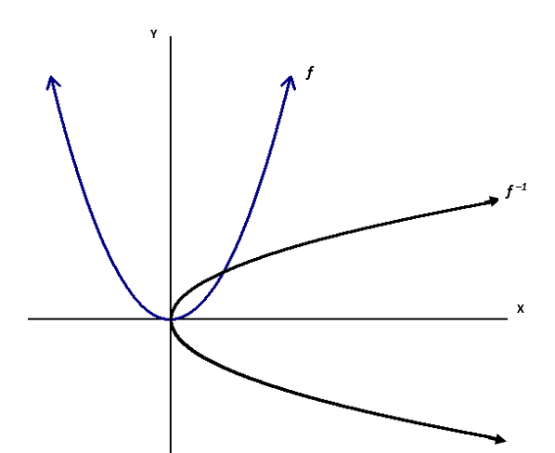

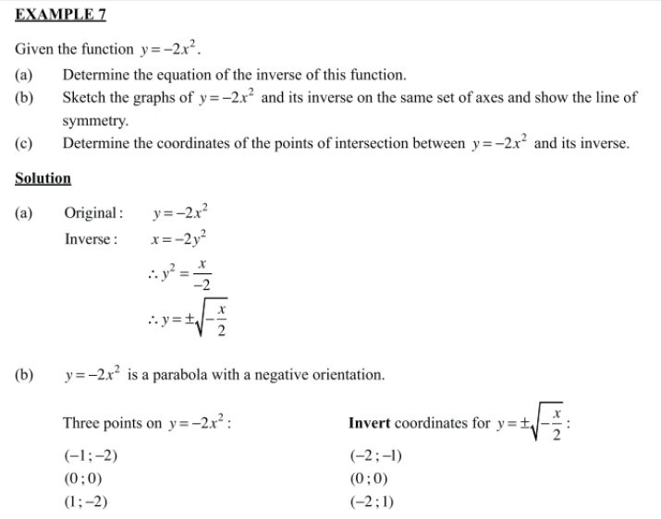

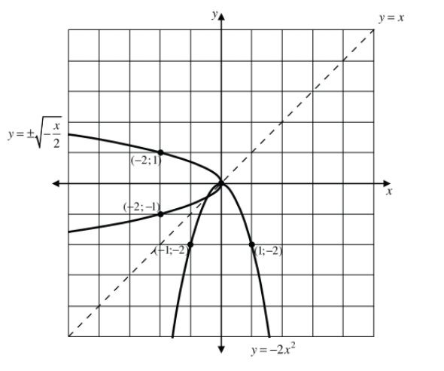

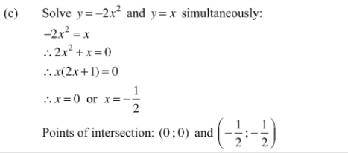

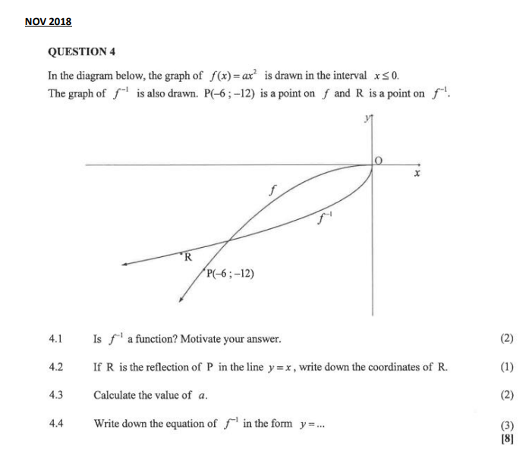

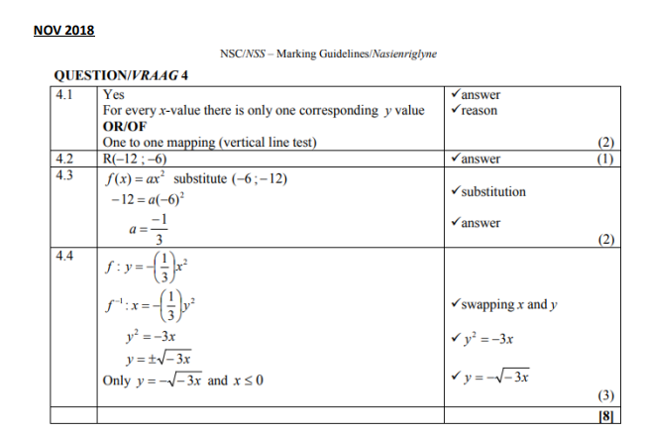

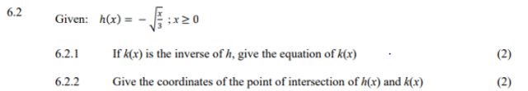

**SOLUTION**

